**NETWORK SECURITY FUNDAMENTALS LABORATORY WORK PART 1**

Family Name: David Selvam

Given Name: Visahl Samson

Student Number: 10498743

Unit code and Title: CSI3207 Network Security Fundamentals

Name of Lecturer: Loh Kah Yee

Campus: PSB Academy, Singapore

Course: Bachelors of Science in Cyber Security (FT)

Due Date: 11th October 2019

Contents

Introduction 3

Design 3

Server configuration 4

Client system configuration 11

# Introduction

The purpose of this laboratory work is to establish a secure VPN connection between server and client using the VPN service known as OpenVpn. For client and server purposes I have already installed Ubuntu (as server) and Kali Linux (as Client) in VMware work station. The detailed configuration, design and laboratory work is explained with appropriate evidence.

# Design

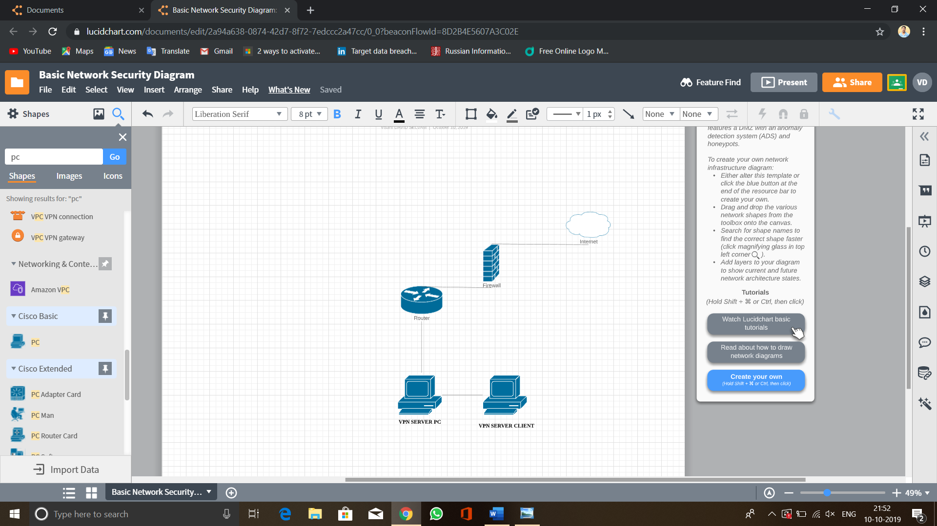

Screenshot Design

The network diagram for this lab activity is consists of 2 machines one is for client and another one is for server. So the Server PC will go through default router gateway and through the firewall and at last will connected to OpenVPN (i.e. mentioned as Internet in design diagram). After that the client connected to VPN server will also connected to the VPN network.

IP address of Server in Wlan - 192.168.92.138, Server tunneling IP - 10.8.0.1

IP address of Client in Wlan - 192.168.92.136, Cleint tunneling IP - 10.8.0.6

# Server configuration

The VPN configuration is begins with server configuration. As I have done in previous lab work here my server OS is Ubuntu and client OS is Kali Linux.

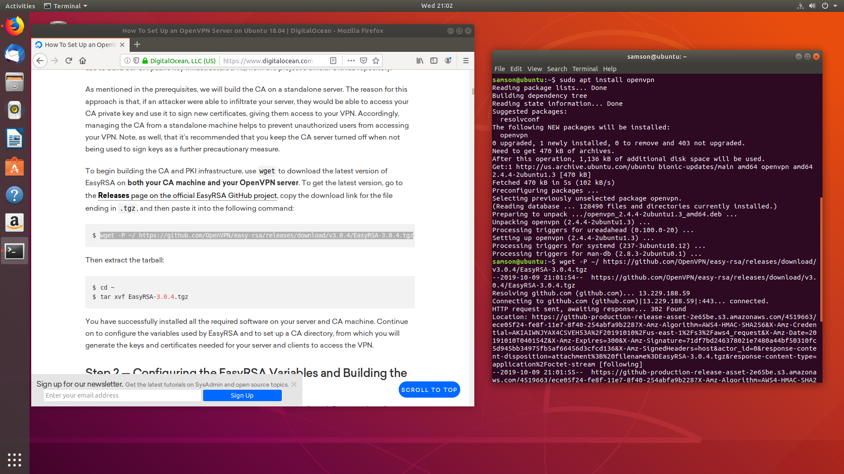

Screenshot Installing OpenVpn and Easy RSA

Given screenshot 2 shows installing the OpenVpn from Ubuntu’s directory since it’s already given with it. It also elucidates that downloading Easy-RSA for making certificate authority.

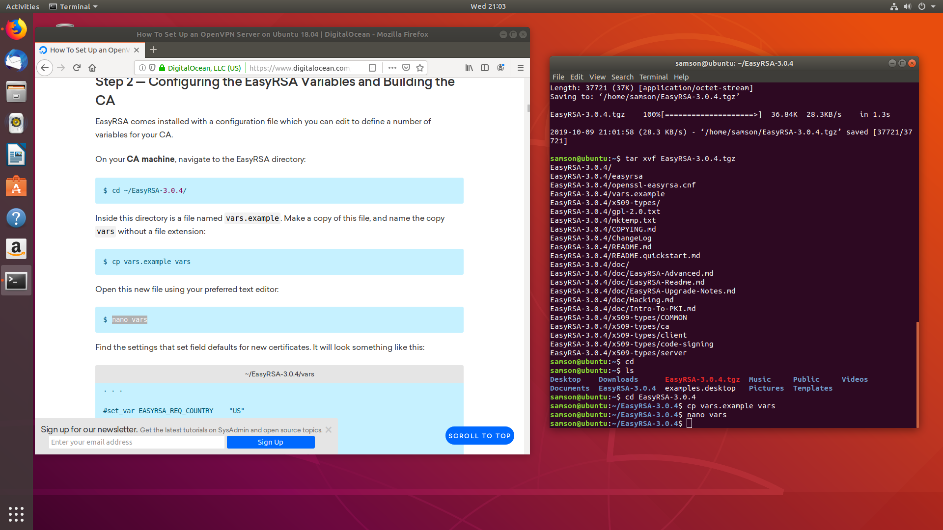

Screenshot Configuring EasyRSA variables

Above screenshot 3 shows editing the EasyRSA variable file. Once I entered the command **nano vars** the output can be found in Screenshot 4.

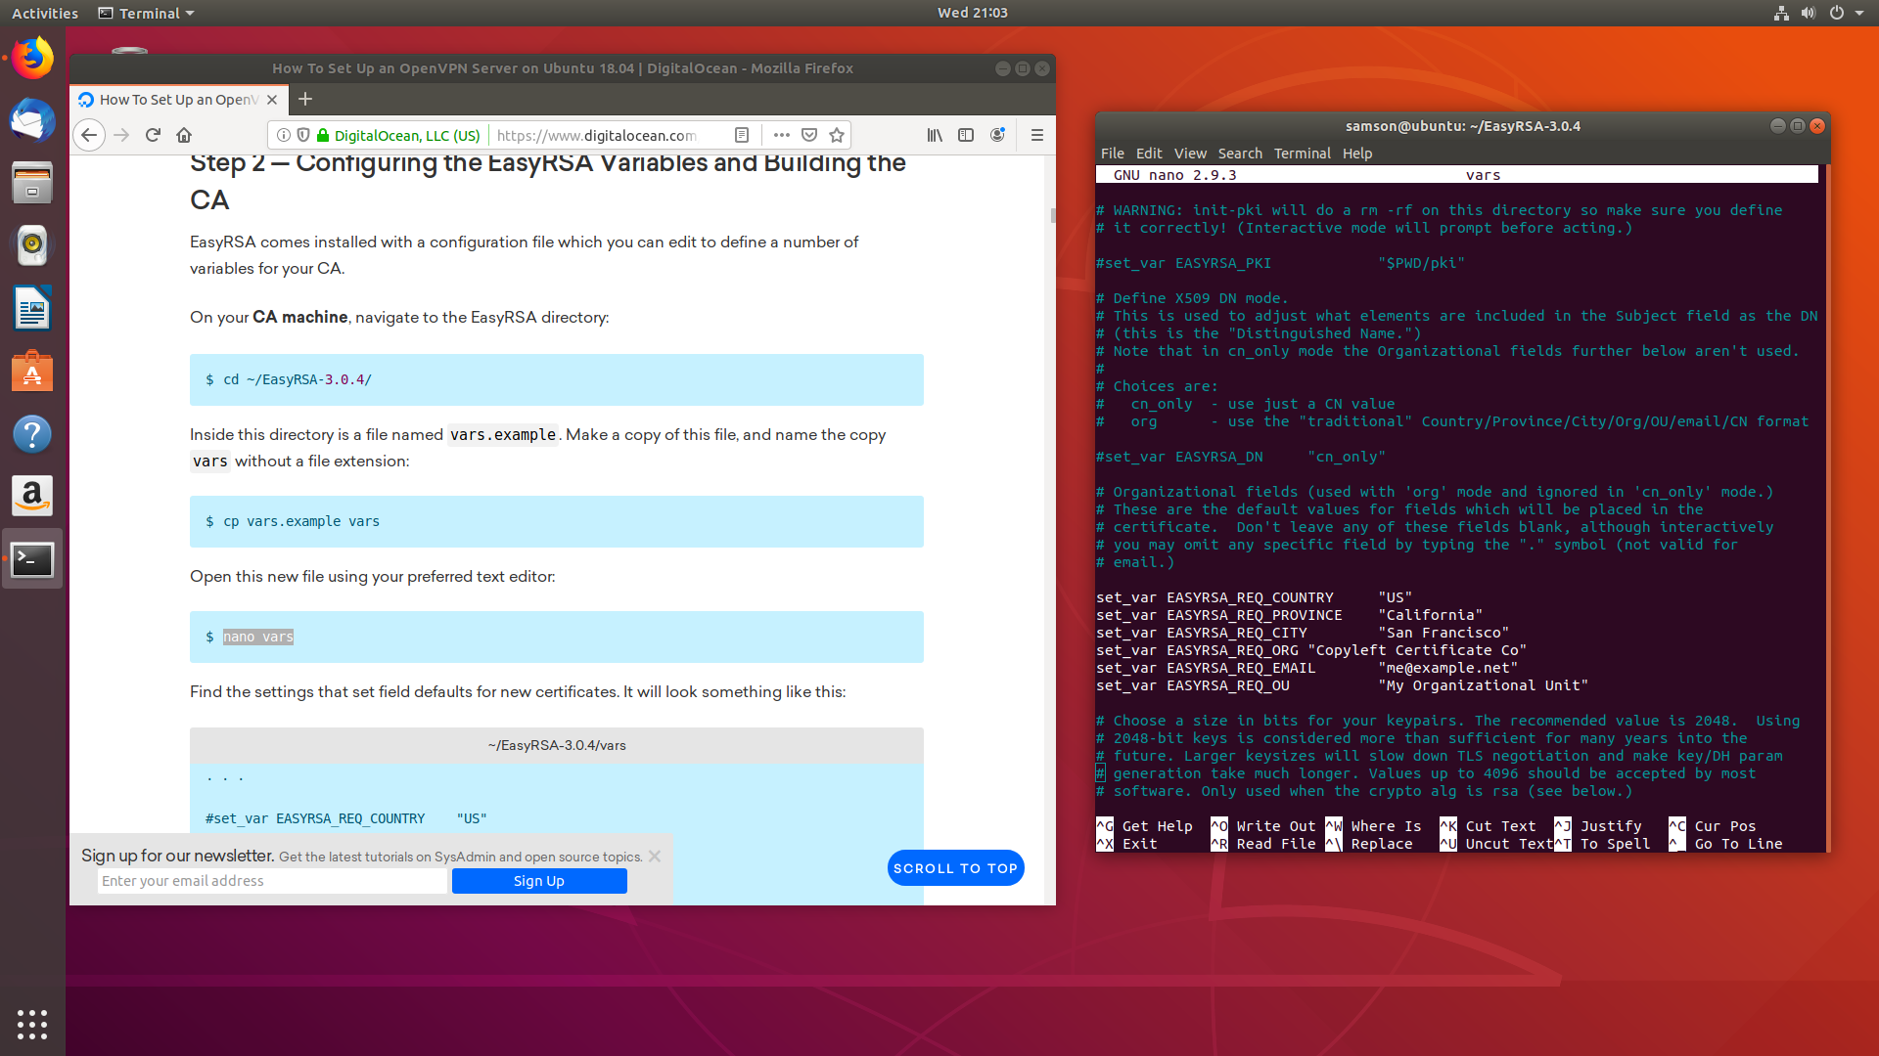

Screenshot EasyRSA Variable file

Once the variable file has been modified, the next step is to initiate public key infrastructure in the server. For that I have used the command **./easyrsa init-pki.** The screenshot has been provided in Screenshot 5.

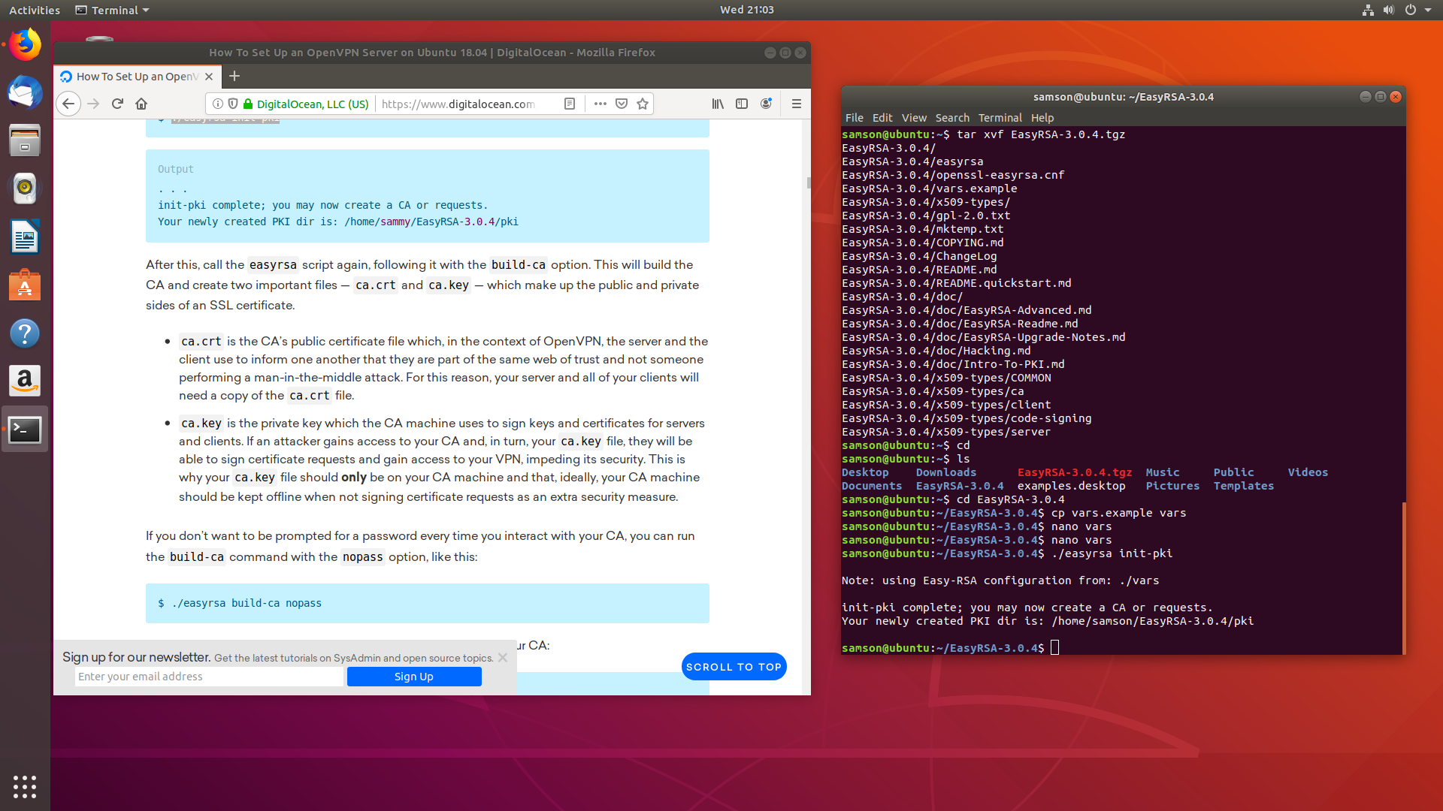

Screenshot Initiating Public key infrastructure

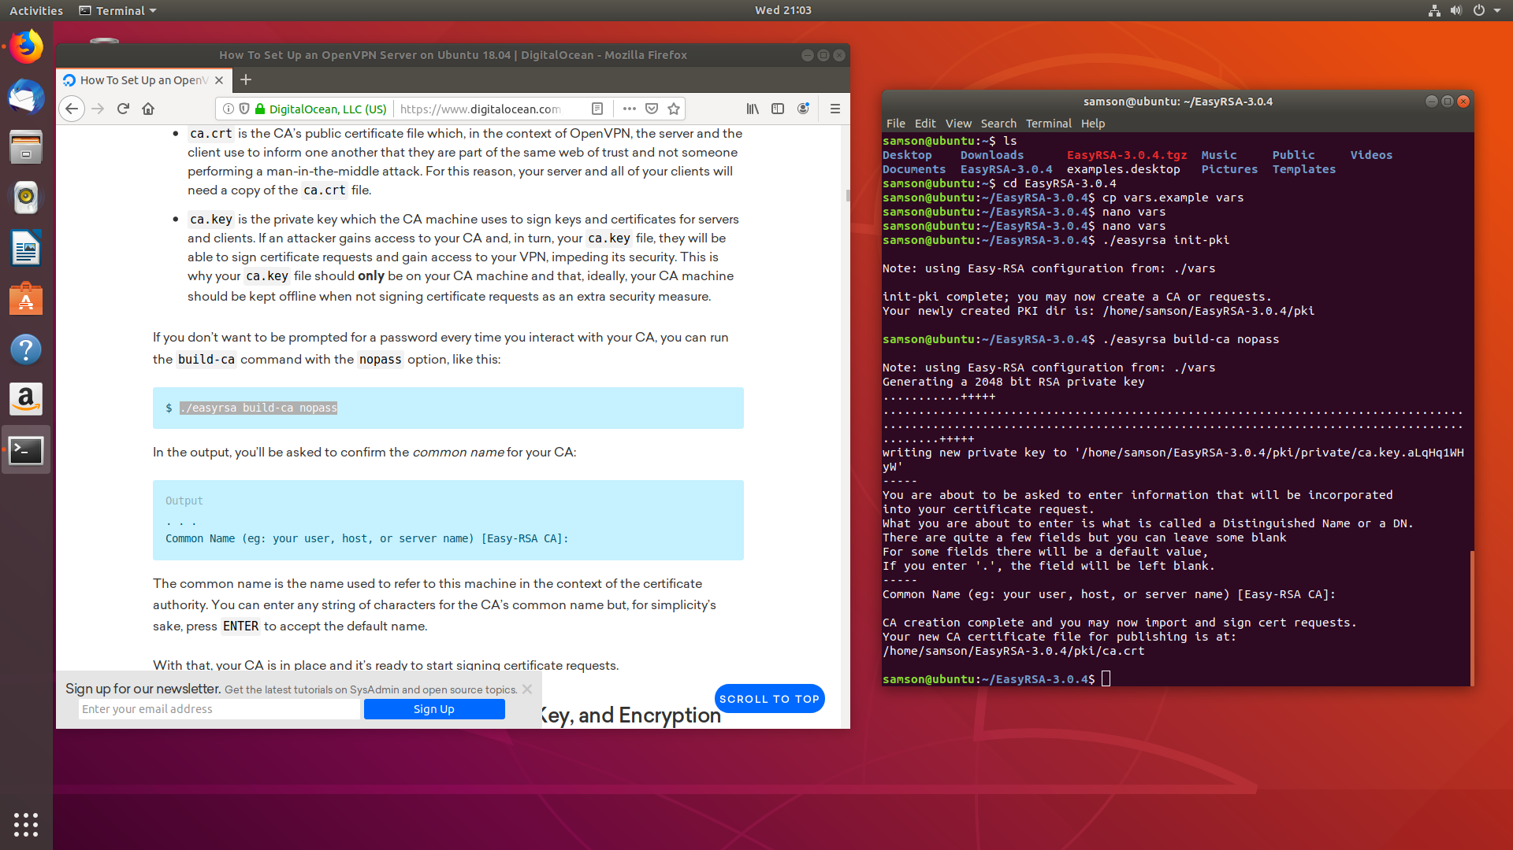After that I have used the command **./easyrsa build-ca nopass** to build the CA. The usage and result of the command has been provided in Screenshot 6.

Screenshot Build-CA

Once the build process got over I have generated server private key and request file. The result is given in Screenshot 7.

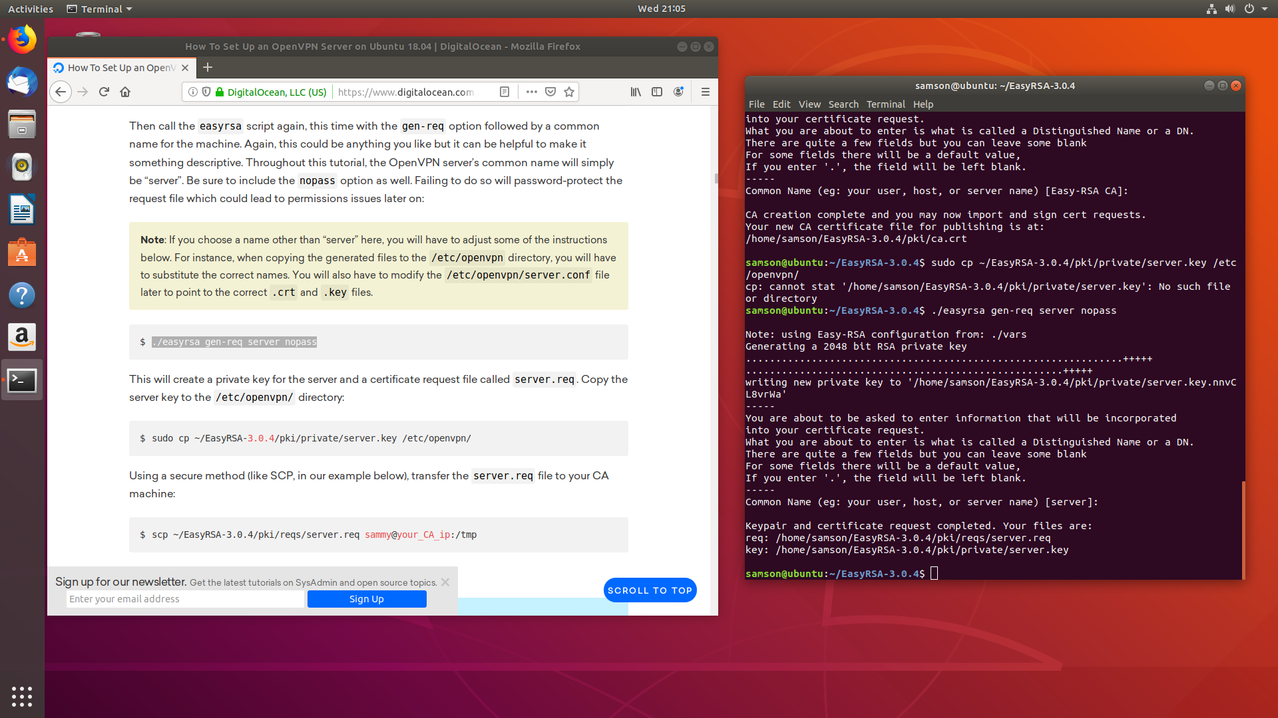

Screenshot Generating private key and request

After that, I have runned the command **./easyrsa sign-req server server** to verify and complete the signing process. The result has been given in screenshot 8.

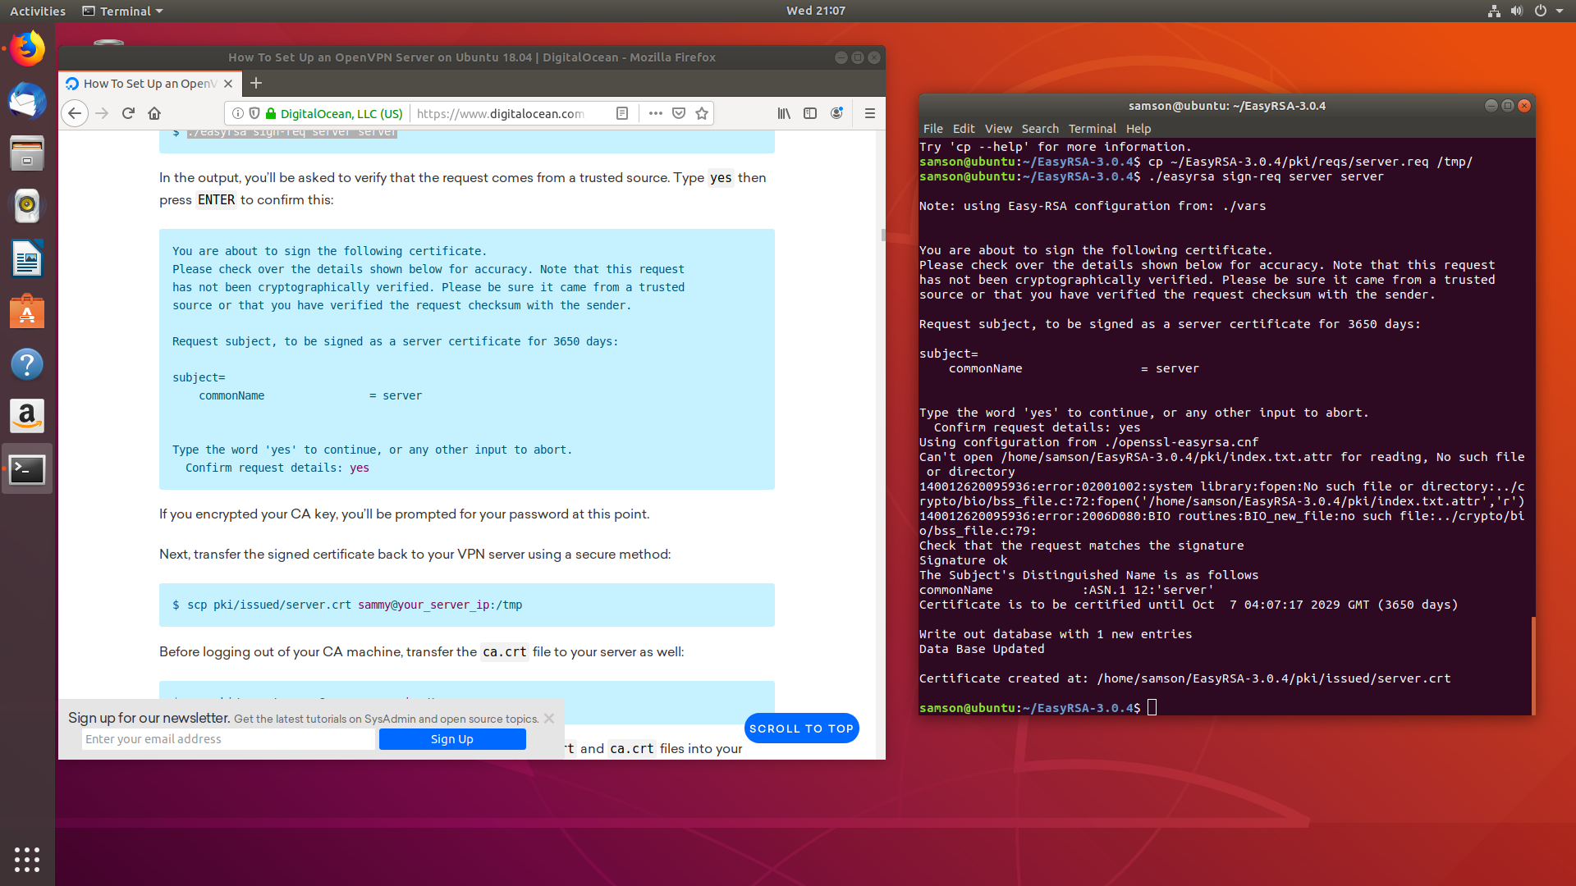

Screenshot making signin

Once the process over I copied the files to the tmp directory and created Diffie-Hellman key. The result is given in Screenshot 9.

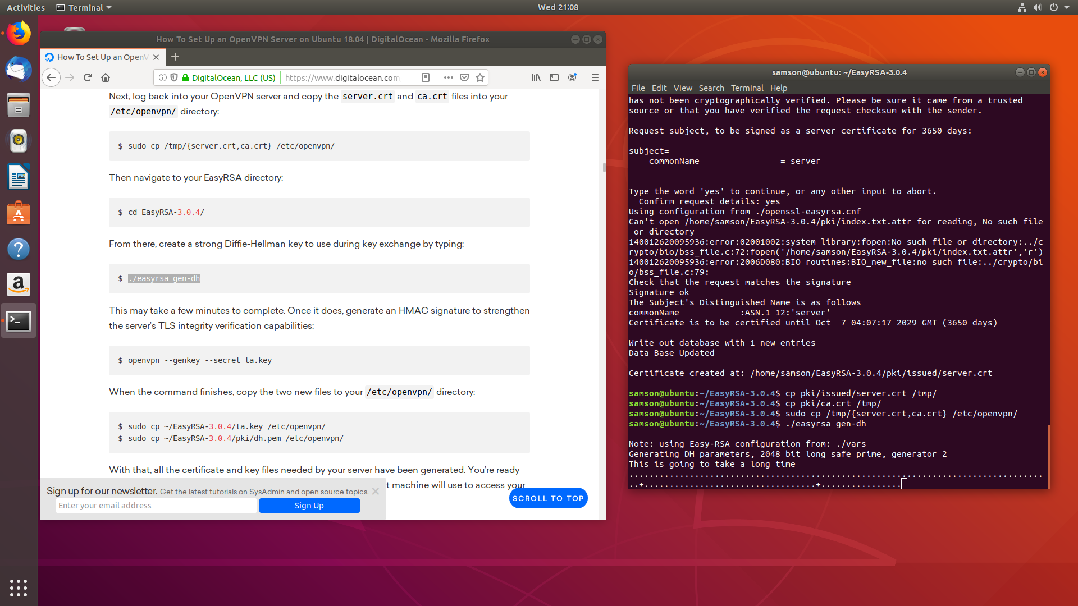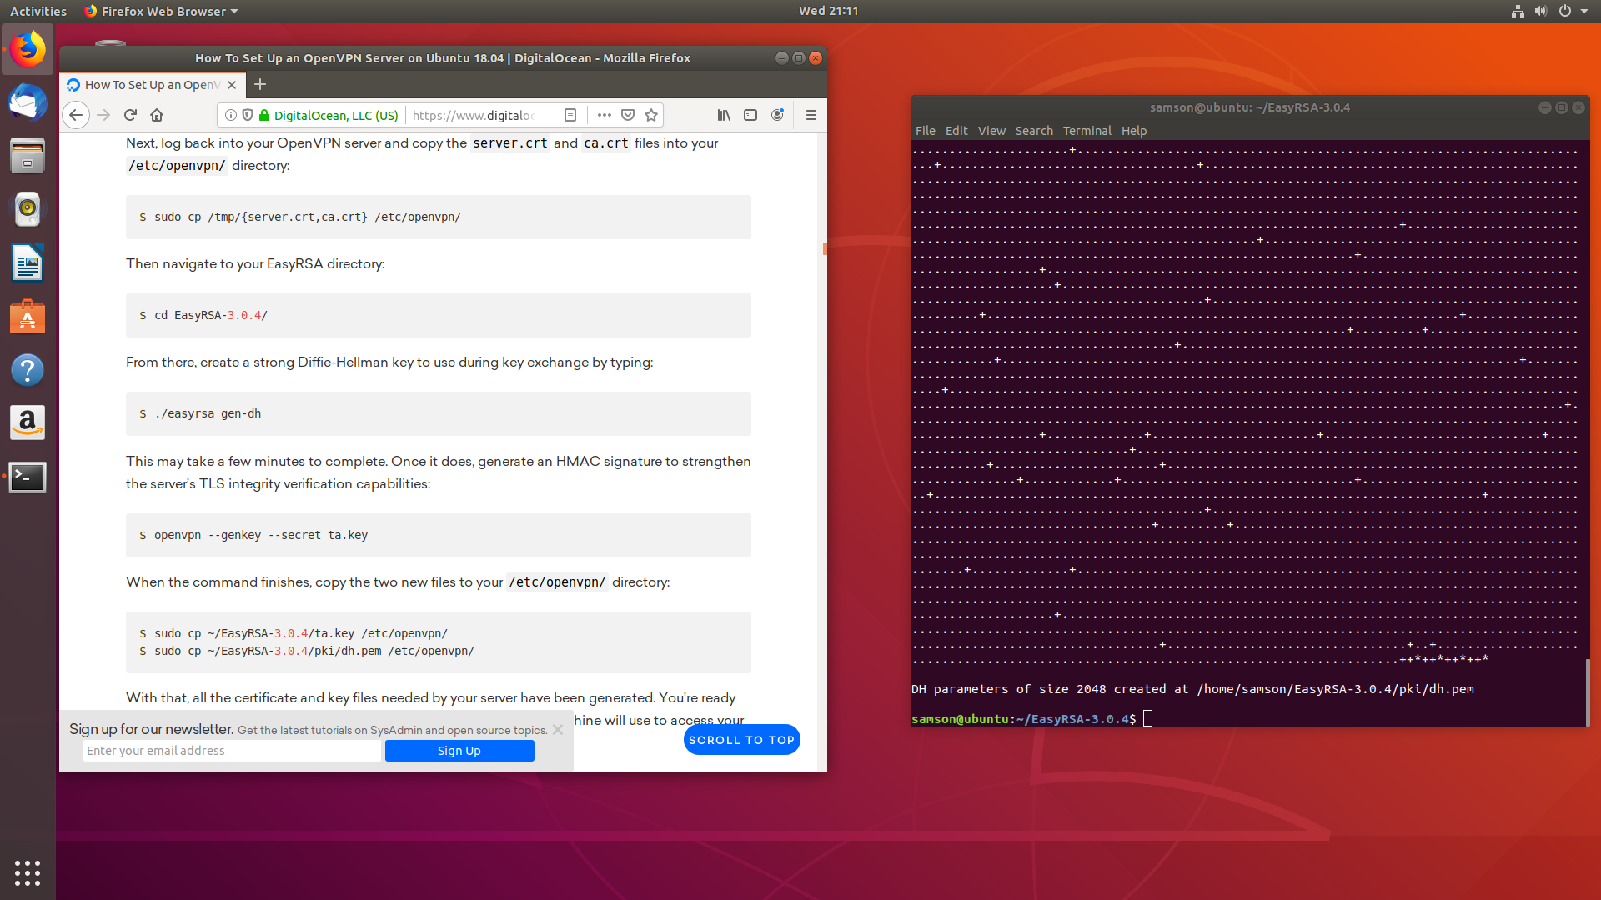

Screenshot Diffie-Hellman key generation

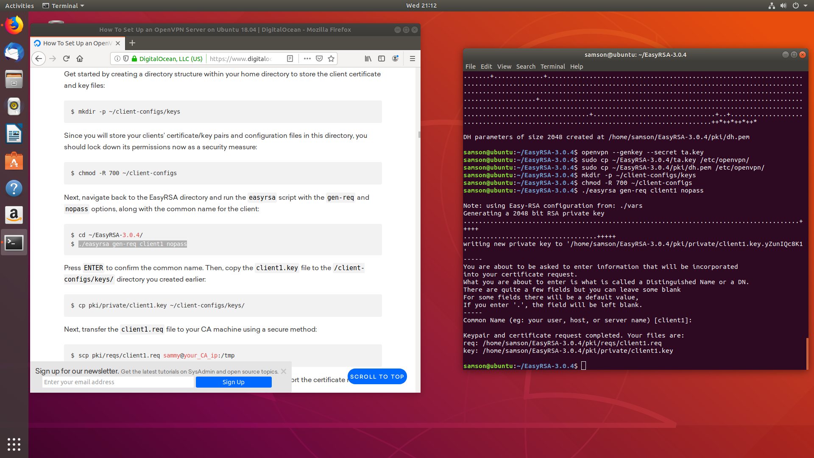

Screenshot client config

Above given screenshot 10 shows creation of client request and key configuration which is important to clients to make connection with the server.

After that, I have moved to configure the OpenVpn configuration file. Here I have uncommented some of the important commands that will enable the OpenVpn to function properly. The usage of command and modification is given in Screenshot 11and screenshot 12.

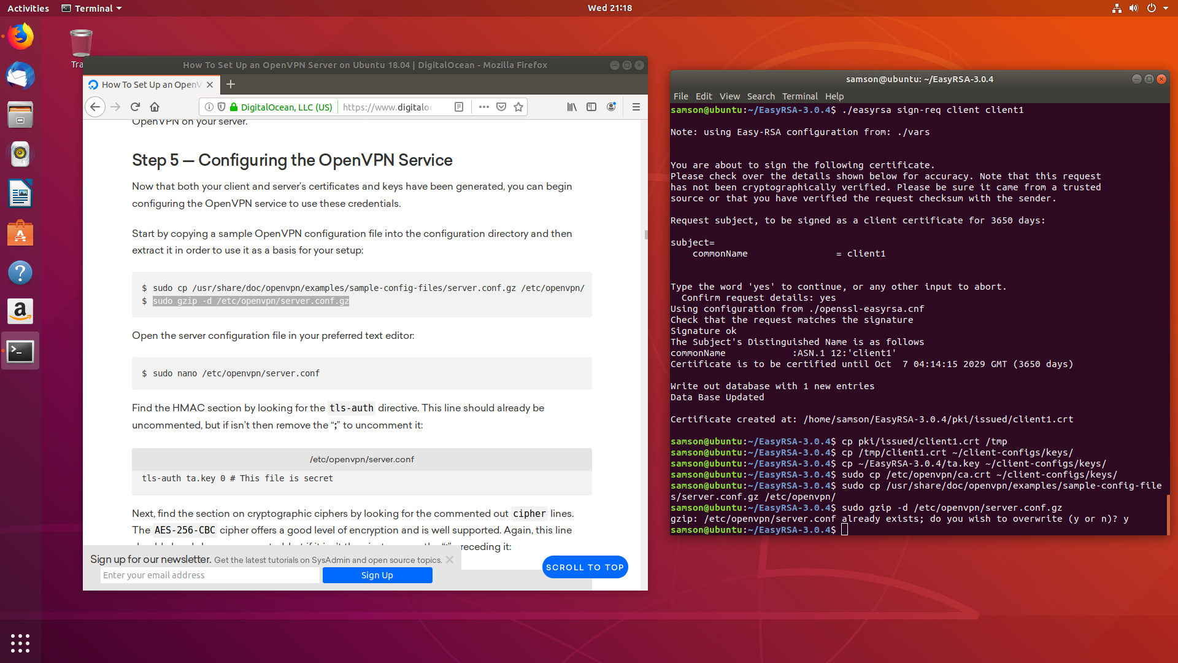

Screenshot Configuring OpenVpn

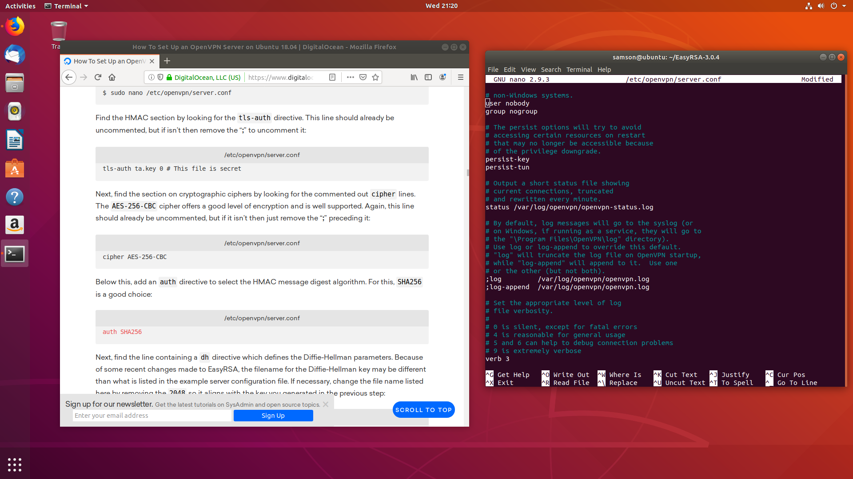

Screenshot Configuring OpenVpn

After this process I have configured the UFW in-order to protect the OpenVpn server from execution. The evidence is given in Screenshot 13.

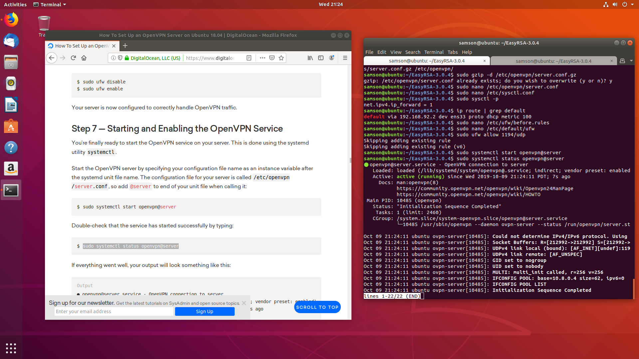

Screenshot configuring UFW

Once the process is over I have started the Openvpn service. The command used here is **sudo systemctl start openvpn@server** the usage of command has been given in screenshot 14.



Screenshot Starting openvpn

Once I started the Openvpn server I have used the command **sudo systemctl status openvpn@server** to know the OpenVpn status. The result has been provided in Screenshot 15.

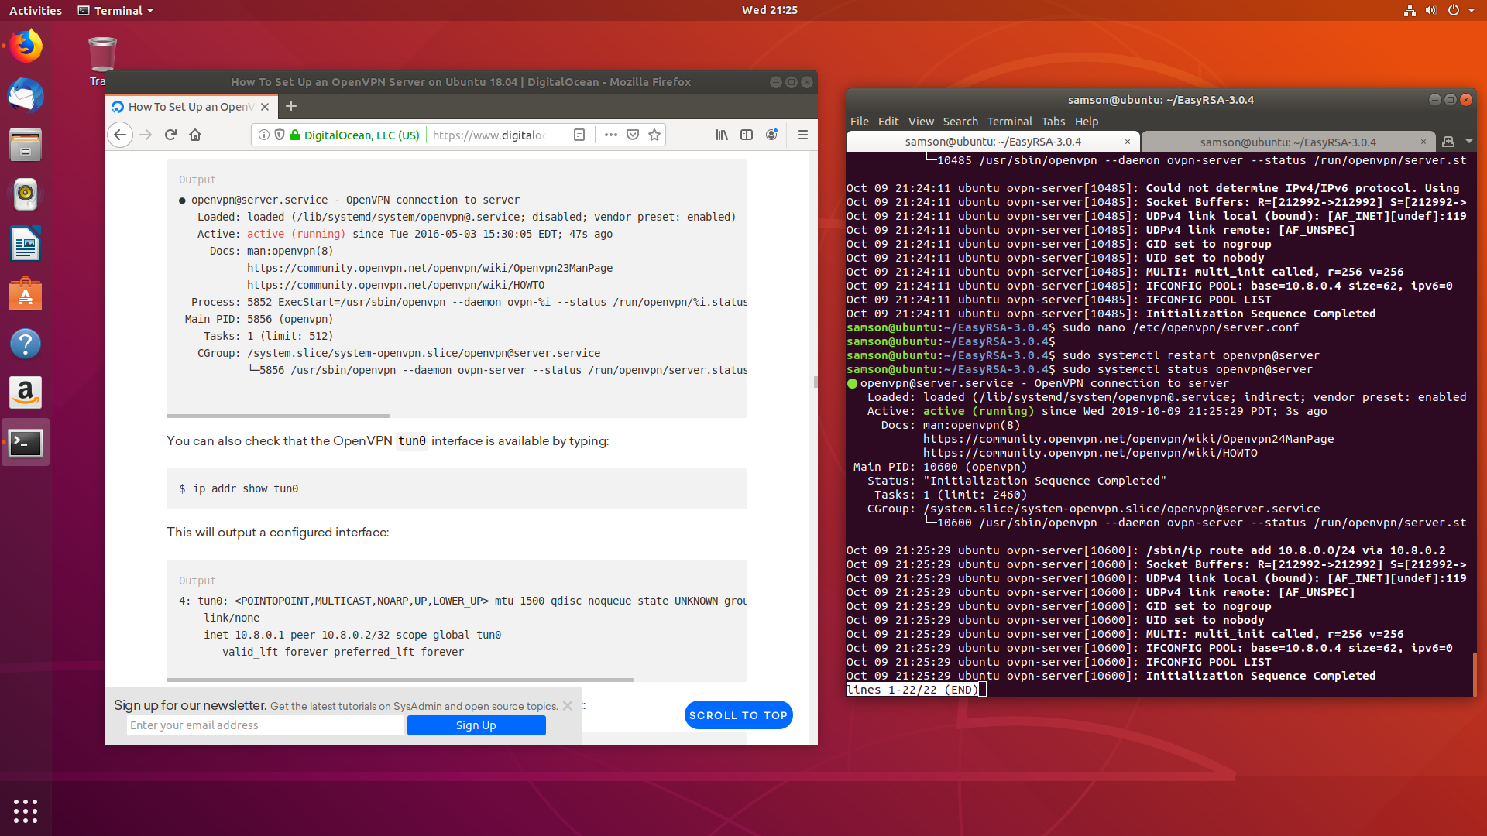

Screenshot Checking OpenVpn status

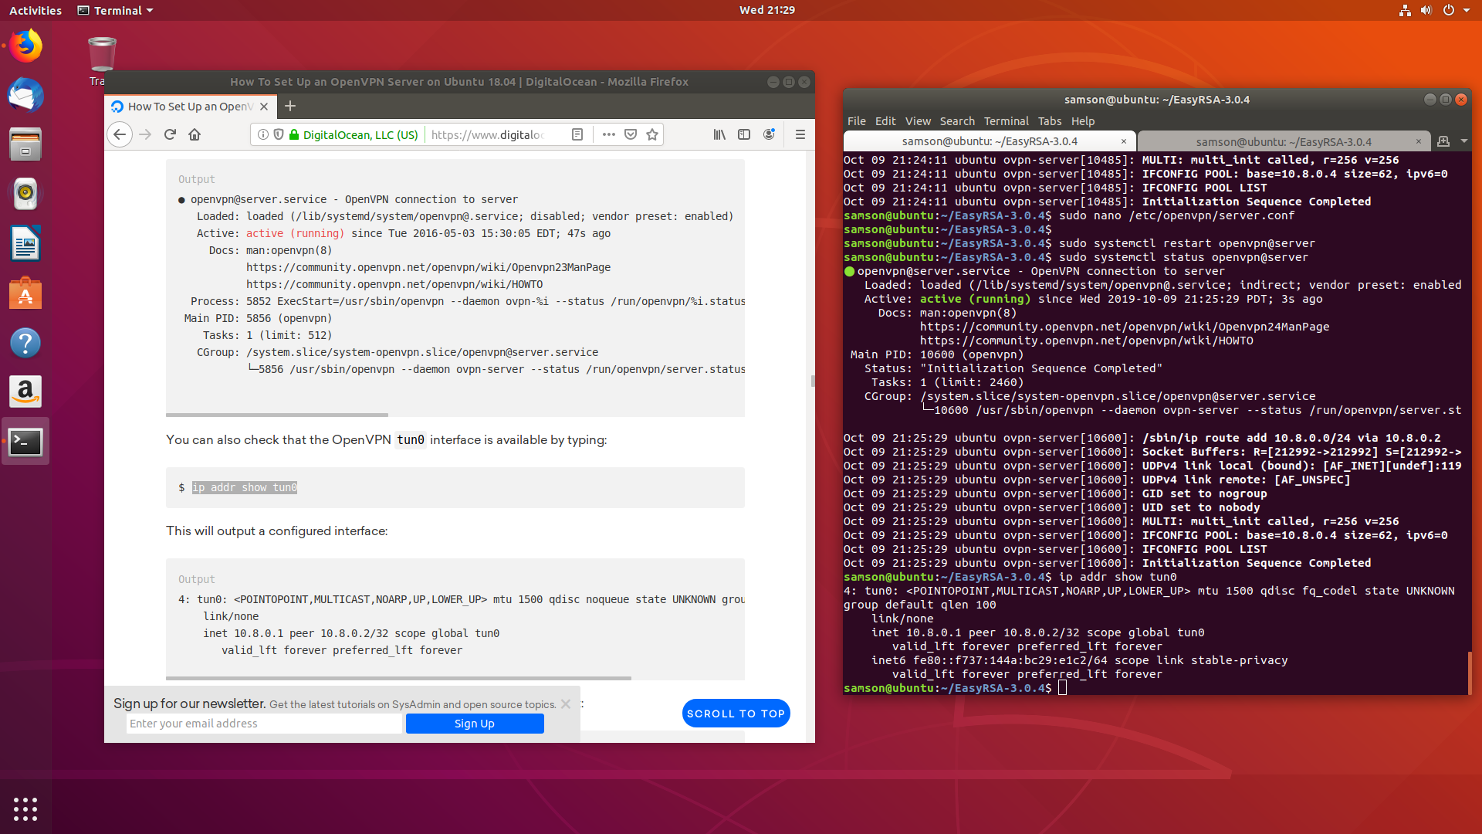

Screenshot Checking VPN Tunnel

After found the OpenVpn status I have used the command **ip addr show tun0** to ensure that tunnel for VPN connection has been formed. The result it given in Screenshot 16.

So, once I ensure the tunnel has been formed I have started to configure the client configuration files from their respective directories.

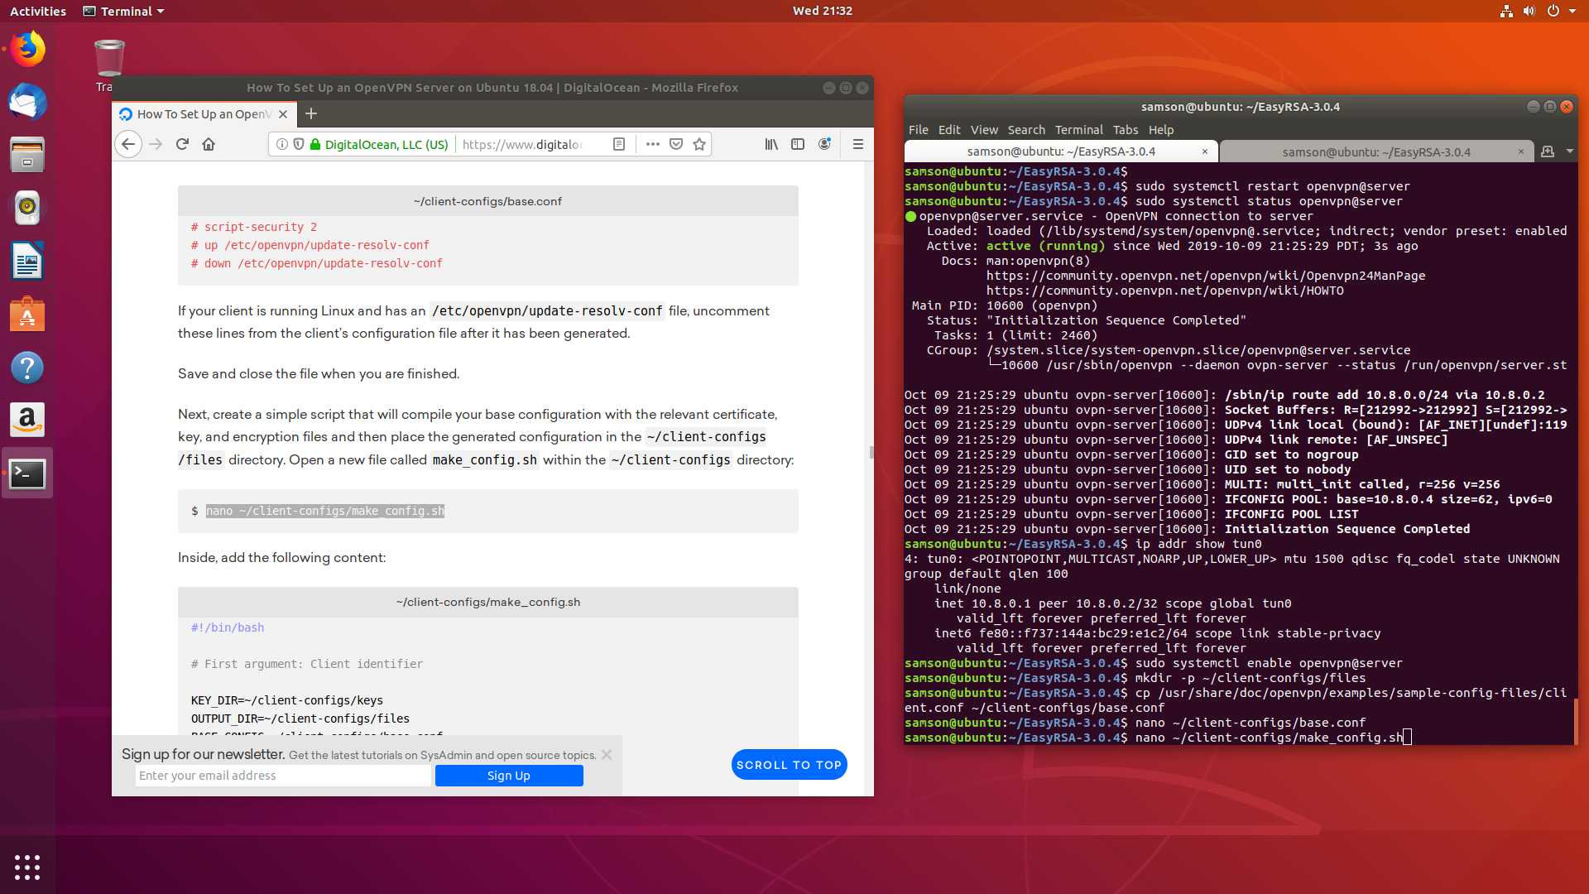

Screenshot Configuring Client configuration files

Above screenshot 17 elucidates that creation of directory for the client configuration, copying the client configuration file from openvpn directory. Also, I have used Nano editor to edith the client configuration files.

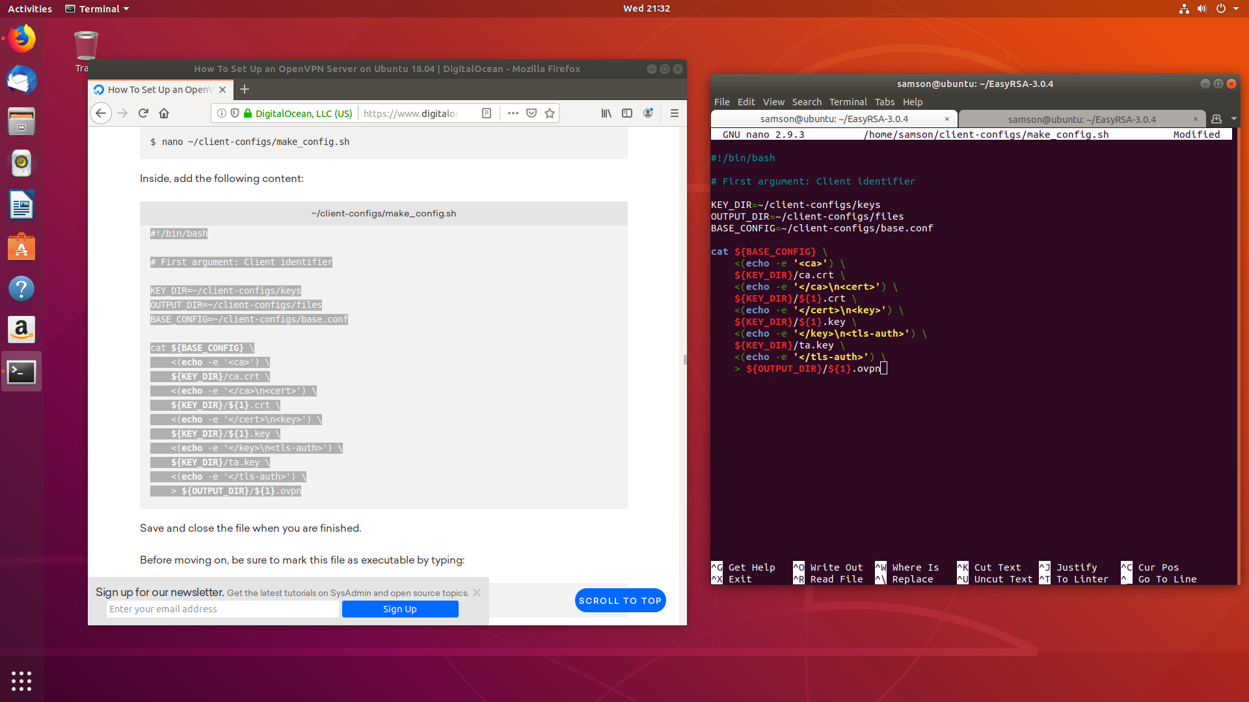

Screenshot Configuring client config file

Given screenshot 18 elucidates configuring the client make_config.sh file. This is the configuration file that gonna create client openvpn configuration for the clients.

Once the configuration is over I executed the script and ensured that client.ovpn file has been created the result is provided in screenshot 19.

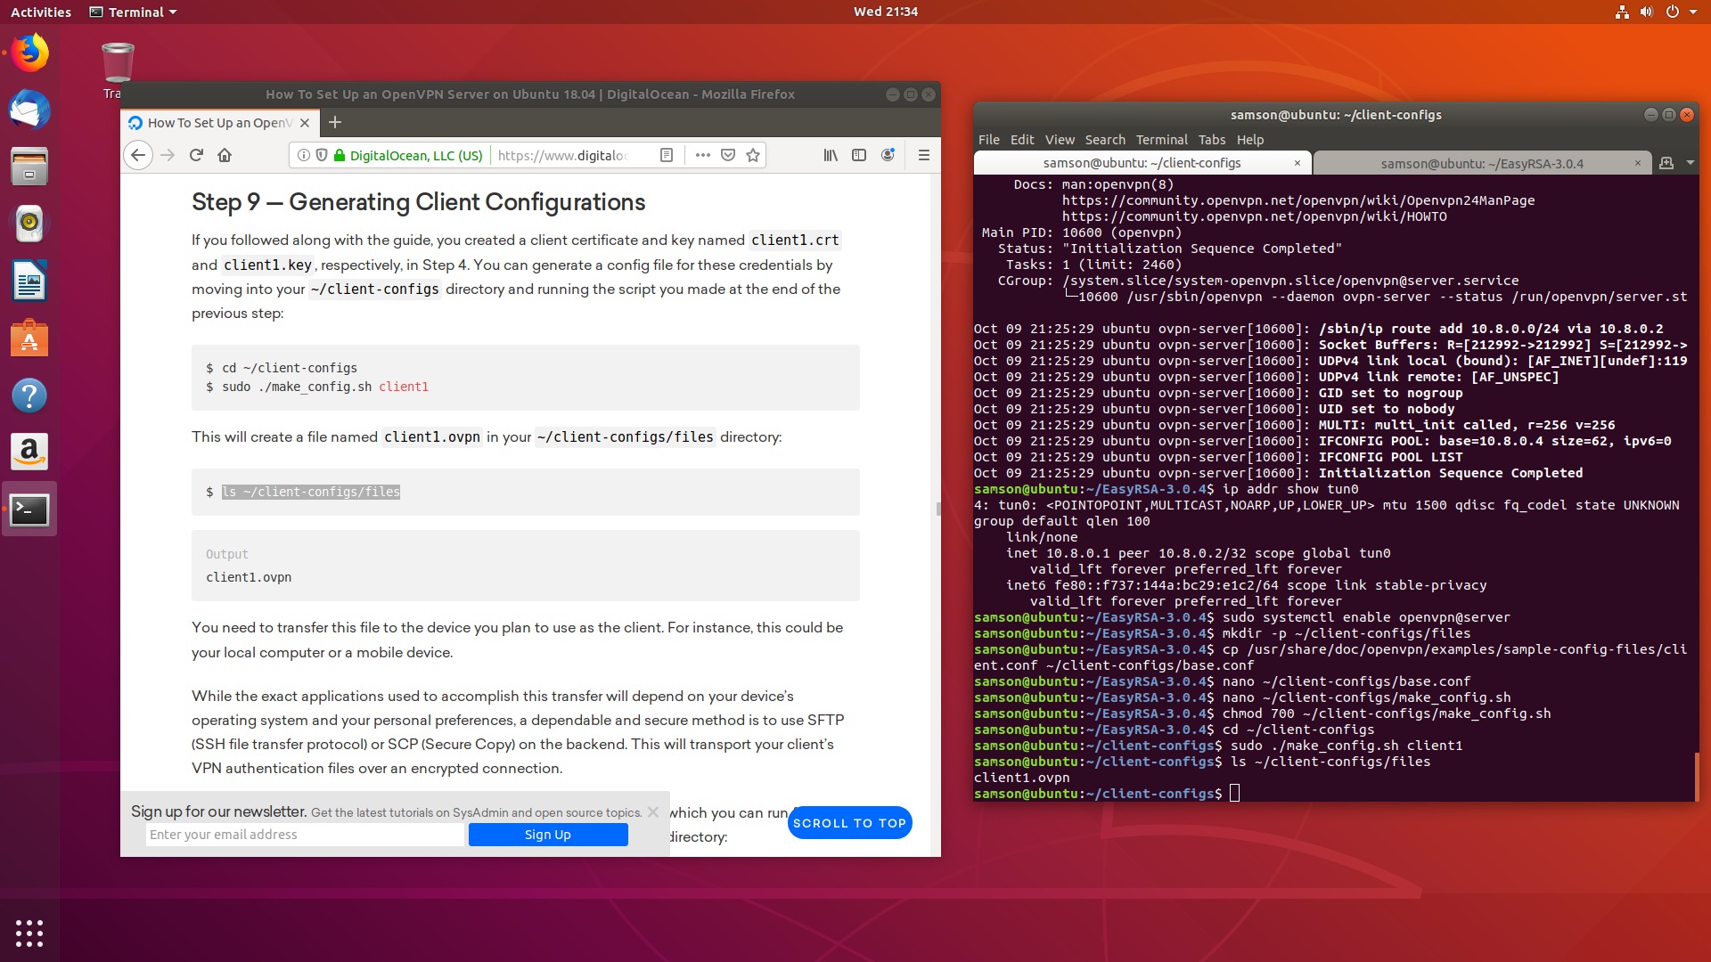

Screenshot Ensuring Client OVPN file has been created

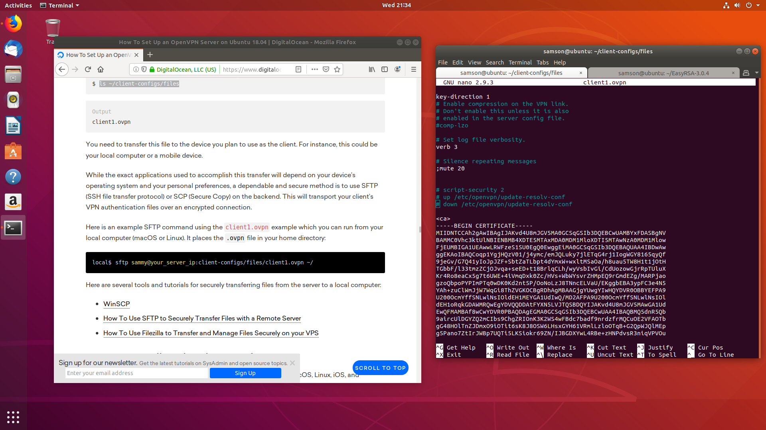

Screenshot Content in Client-Config file

Screenshot 20 elucidates the contents that are present inside the client-config file. This includes the Certificate that enable the client to connect to the server.

After that I have closed the file and transfered the client.ovpn file to the client system through ssh.

# Client system configuration

Once the server configuration is completed I have moved to client system configuration. Here my client system is Kali Linux.

To start with I had installed Openvpn in it by using the command **sudo apt install openvpn.** The screenshot is given in Screenshot 21.

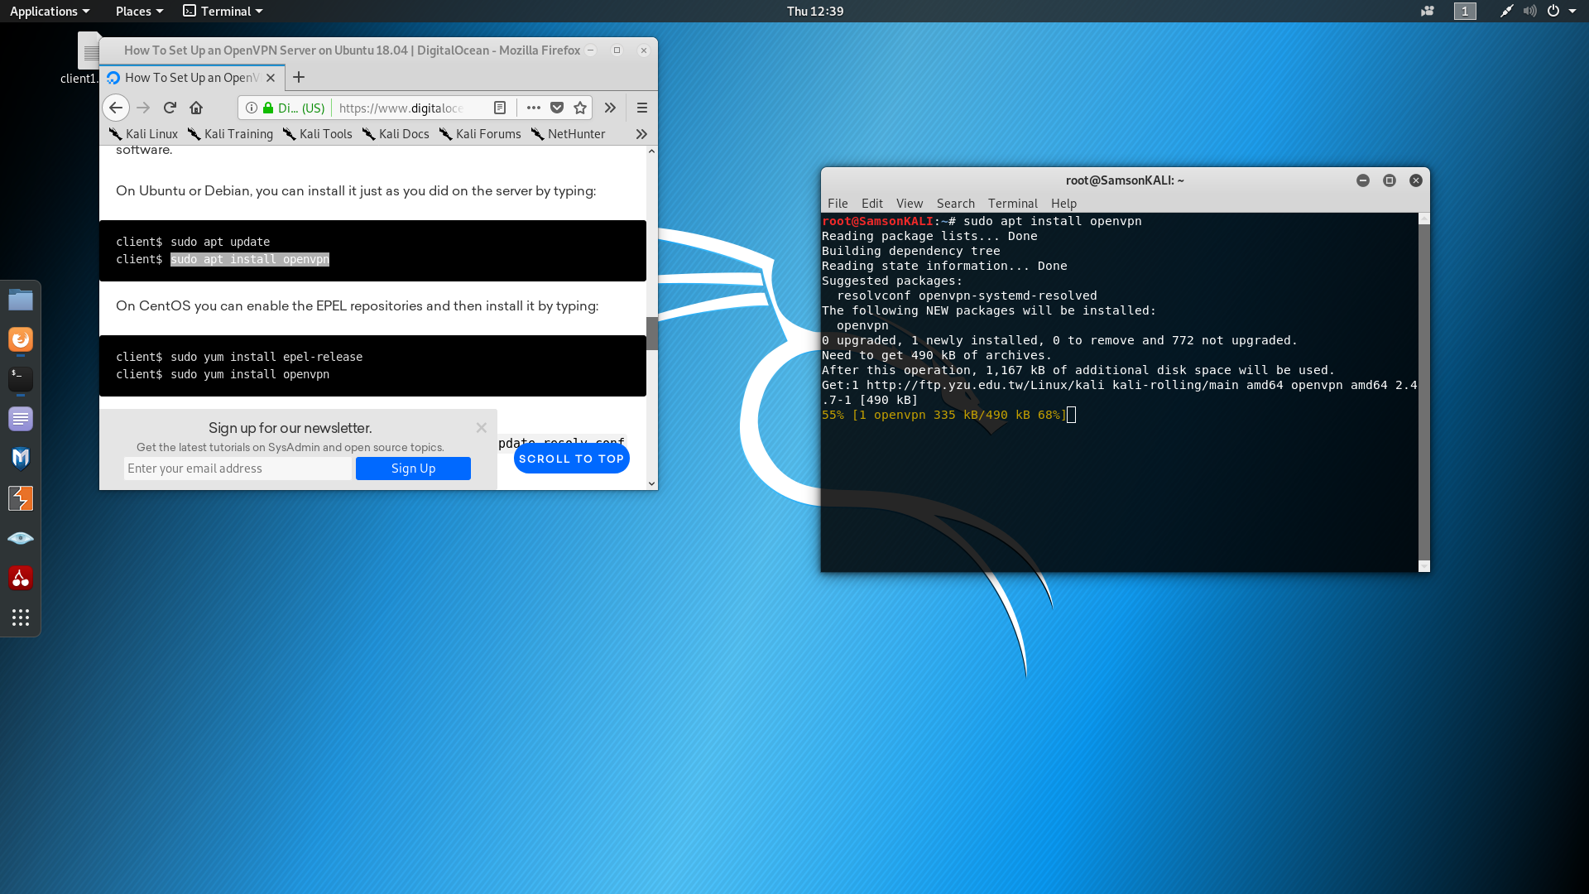

Screenshot Installation of OpenVpn

After that, I have opened the Client1.ovpn file to configure and uncommented the codes. The screenshot provided in Screenshot 22.

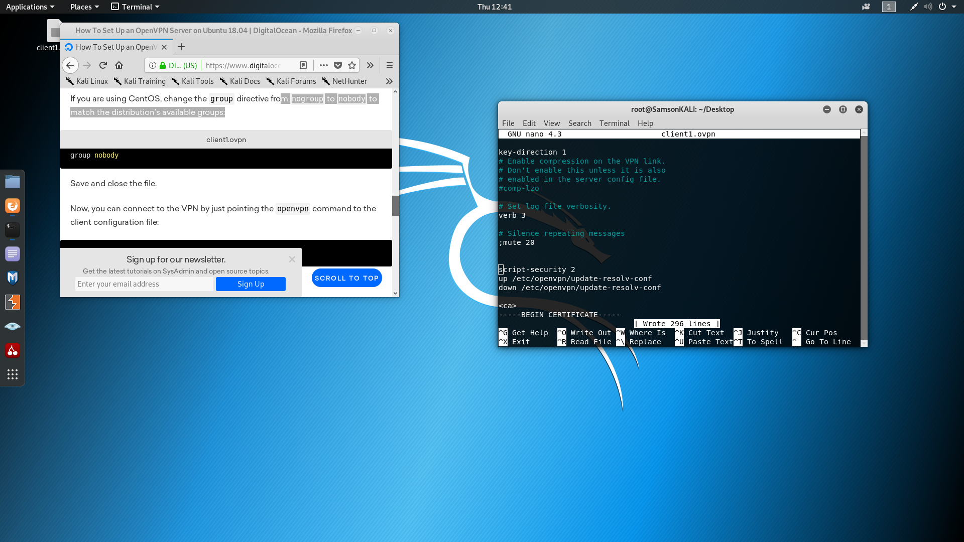

Screenshot Client.Ovpn configuration

Then I have executed the script which makes the connection with OpenVpn. Once I executed it got connected to the VPN server. The result is given in Screenshot 23.

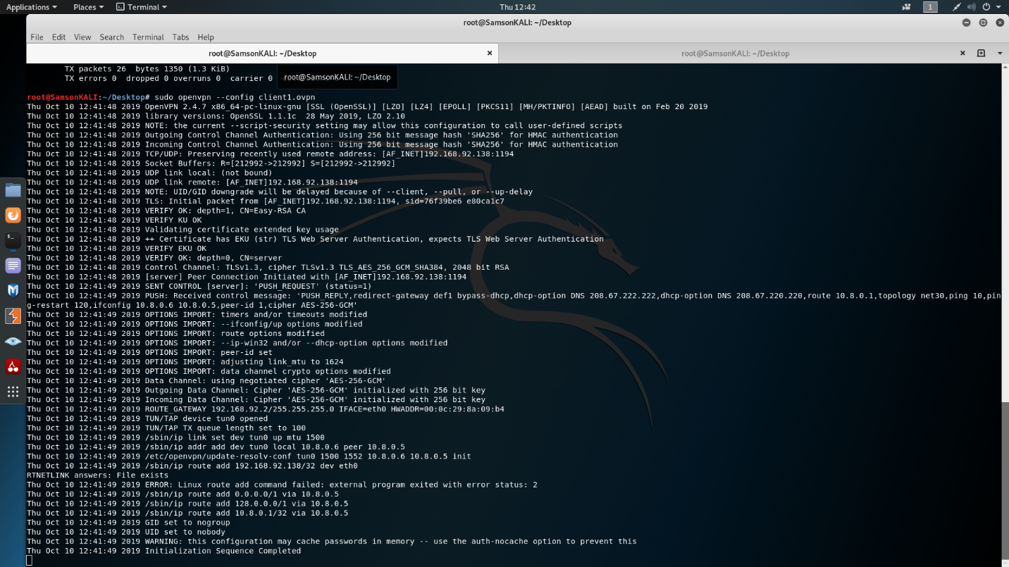

Screenshot Executing Client.Ovpn

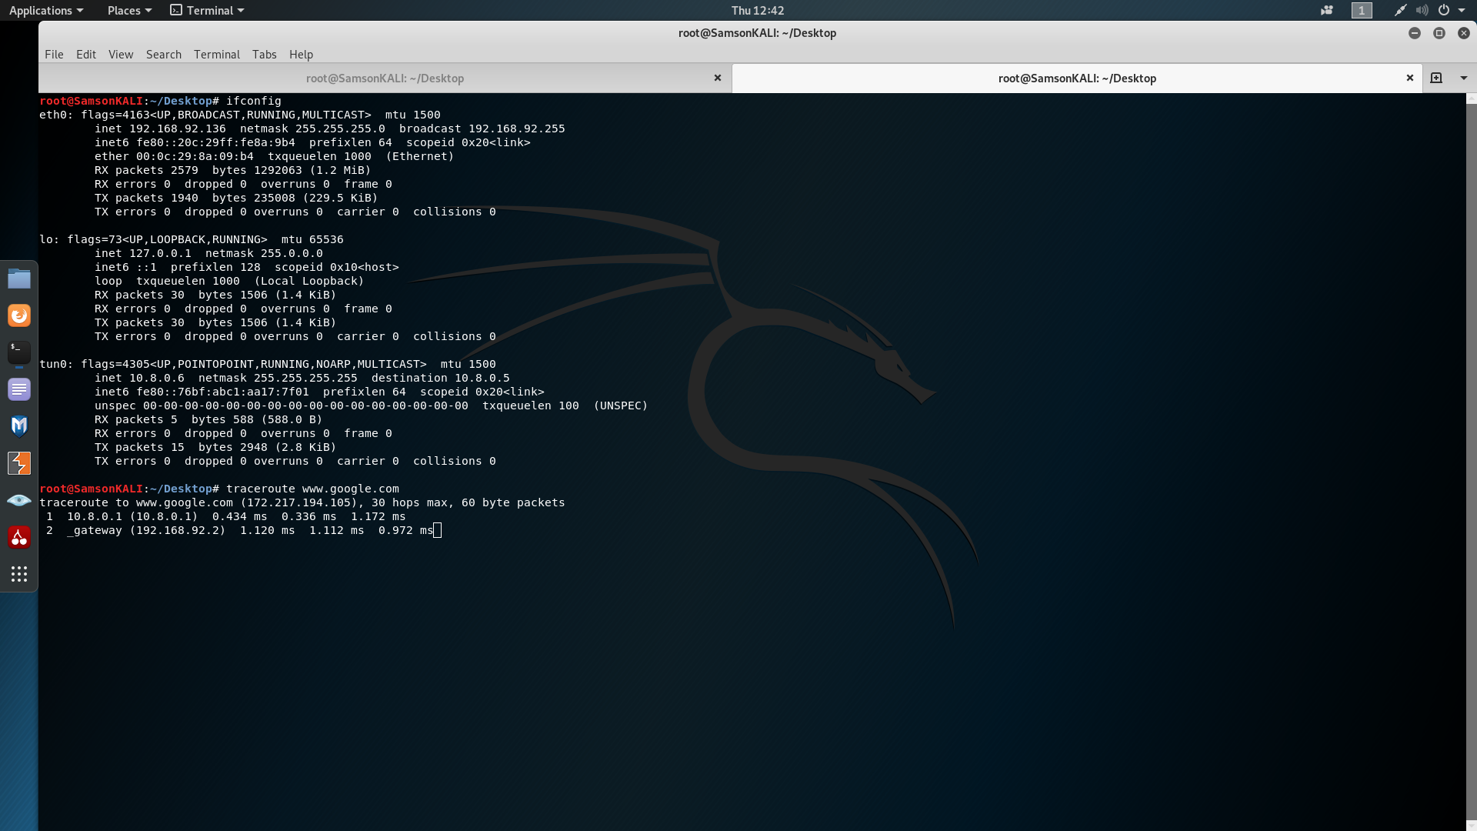

Screenshot Tunneling in Client Machine

Given screenshot 24 shows that tunneling had been created. The IP address allocated for the client machine here is 10.8.0.6.

In order to check the connectivity I executed the **traceroute** command. The result is given in Screenshot 25.



Screenshot Traceroute command